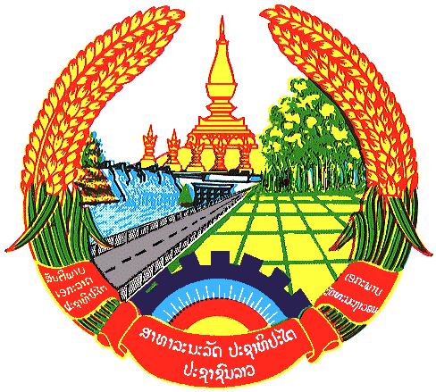

Statement by the delegation of the Lao PDR
At the 26th Session of UPR Working Group
Geneva, 31 October 2016 – 11 November 2016
----------------

Review of Syria Arab Republic : 31 October 2016, at 14:30 - 16:00 hours

Mr. President,

The Lao delegation warmly welcomes the delegation of the Syrian Arab Republic to the UPR Working Group and would like to thank for their comprehensive presentation on the promotion and protection of human rights in the country.

My delegation notes that, despite the conditions of the country is experiencing and attacking by armed groups, the Government of Syria has demonstrated efforts to strengthen human rights in the country, in particular efforts on empowering women in all level of decision-making and ensuring the full participation of women in political, economic and social life. Lao PDR recommends that Government of Syria continue to enhance women’s empowerment and greater represent women in all sectors.

Lao PDR notes Syria’s efforts to enhance the rights of education by increased of total expenditure on all sectors to education sector up to 8,4 % in 2015 compared to 4.4% in 2014, We further recommend that Syria Government ensures equal access to education of vulnerable people including women, children and persons with disabilities.

Mr. President

While my delegation notes ongoing complexity in promotion and protection of human rights in Syria due to uncertainty situation in the country. However we do hope that the Government of Syria will be able to solve the conflicts and overcome all difficulties and bring peace and security back to Syria people. In this critical juncture, encouragement and assistance from international community is necessary needed for Syria in order for them to achieve their international obligation on human rights.

We wish Syria Arab Republic every success in its Second Cycle of UPR.

I thank you, Mr. President

